**Date: 19/03/2022**

**Walchand College of Engineering, Sangli**

**Department of Computer Science and Engineering**

**Software Engineering Tools Lab**

**Assignment No 4**

**(Module 4- Configuration management tools)**

**Name : Sumedh Milind Bhatkar**

**PRN No : 2019BTECS00045**

**Batch : T6**

Q 1. Differentiate **Chef Vs Puppet Vs Ansible Vs Saltstack** w.r.t properties given below

1. Owner/ Company
2. Open/free/proprietary
3. Size
4. Configuration type(push/pull)
5. Components
6. Written in language
7. Tasks that can be performed (infrastructure/code management etc.)
8. Advantages
9. Disadvantages
10. Website
11. Installation prerequisite

Ans:

|  |  |  |  |  |
| --- | --- | --- | --- | --- |
| **Properties** | **Chef** | **Puppet** | **Ansible** | **Saltstack** |
| Owner/Company | Opscode | Yvonne Wassenaar | Michael DeHaan | VMware |
| Open/free/proprietary | Open source | Open source | Open source | Open source |
| Size | 0.08 mb | 0.08 mb | 0.08 mb | 0.08 mb |
| Configuration type(push/pull) | Pull based | Pull, Push | Push based | Push based |
| Components | 3 main components   1. Workstation 2. Server 3. Nodes | Manifests  Module  Resource  Factor  M-collective  Catalogs  Class  Nodes | Inventory  Playbooks  Plays  Tasks  Roles  Handlers  Templates  Variables | Salt Master  Salt Minions  Execution Modules  Formulas (States)  Grains  Pillar  Top File  Runners  Returners  Reactor  Salt Cloud/Salt Virt  Salt SSH |
| Written in language | Ruby and Erlang | Ruby | Ruby, Python | Python |
| Tasks that can be performed (infrastructure/code management etc.) | Deployment task  In devops | Deployment task  In devops | Deployment task  In devops | Deployment task  In devops |
| Advantages | 1.Manages huge amount node  2.Write once  deploy many times  3.High availability | 1.Reduce downtime  2.Faster deployment  3.Easy automation | 1.Simple to learn  2.Easily understand to  Python  3.No dependency on agents | 1. Flexible  2.Python api  3.Parallel execution |
| Disadvantages | 1.Not good documentation  2.Not easy to learn if you don’t know ruby | 1.Not good documentation  2.Not easy to learn if you don’t know ruby  3.Not suitable for small businesses | 1.Insufficient UI  2.Limited windows  Support  3.Not have experience | Not good UI |
| Website | www.chef.io | www.puppet.com | www.ansible.com | saltprojects.io |
| Installation prerequisite | 4 GB RAM | 4 GB RAM | 4 GB RAM | 4 GB RAM |

Q 2. What are the different flavors of **Chef configuration management tool**?

Ans: Chef comes in various flavors, such as Chef Solo, which has no remote server and cookbooks are located on the local site itself.

There’s also Hosted Chef, where a Chef server is provided as a service on the cloud. Thus, there is no need to set up a server yourself.

If you want traditional Chef architecture, there’s Chef Client/Server. With this flavor, a hosted remote server communicates between the workstation and node.

Finally, there is a Private Chef, which is the enterprise version of Chef. With this flavor, the server is hosted within the enterprise infrastructure.

Q 3. What is **Pull and Push** configuration?

Ans: Push configuration entails the server pushing configuration to the nodes.  Pull configuration involves the nodes checking with the server periodically, and fetching the configurations from it.

Q 4. What is **Playbook and Inventory w.r.t Ansible** and **recipe and cookbook w.r.t Chef** configuration management tool?

Ans: **Playbook w.r.t. Ansible**: A playbook is where you define how to apply policies, declare configurations, orchestrate steps and launch tasks either synchronously or asynchronously on your servers. Each playbook is composed of one or more “plays”. Playbooks are normally maintained and managed in a version control system like Git. They are expressed in **YAML** (**Y**et **A**nother **M**arkup **L**anguage).

**Inventory w.r.t. Ansible:** The “inventory” is a configuration file where you define the host information.

**Recipe w.r.t. Chef:** It can be defined as a collection of attributes which are used to manage the infrastructure. These attributes which are present in the recipe are used to change the existing state or setting a particular infrastructure node.

**Cookbook w.r.t. Chef:** A cookbook is a collection of recipes. They are the basic building blocks which get uploaded to Chef server.

Q 5. Perform below operations on your machine to check **working of Ansible**

1. Install Ansible
2. Setup an Inventory
3. Create a playbook to install MySQL db on one node.
4. Execute a playbook

Steps to execute installation of ansible:

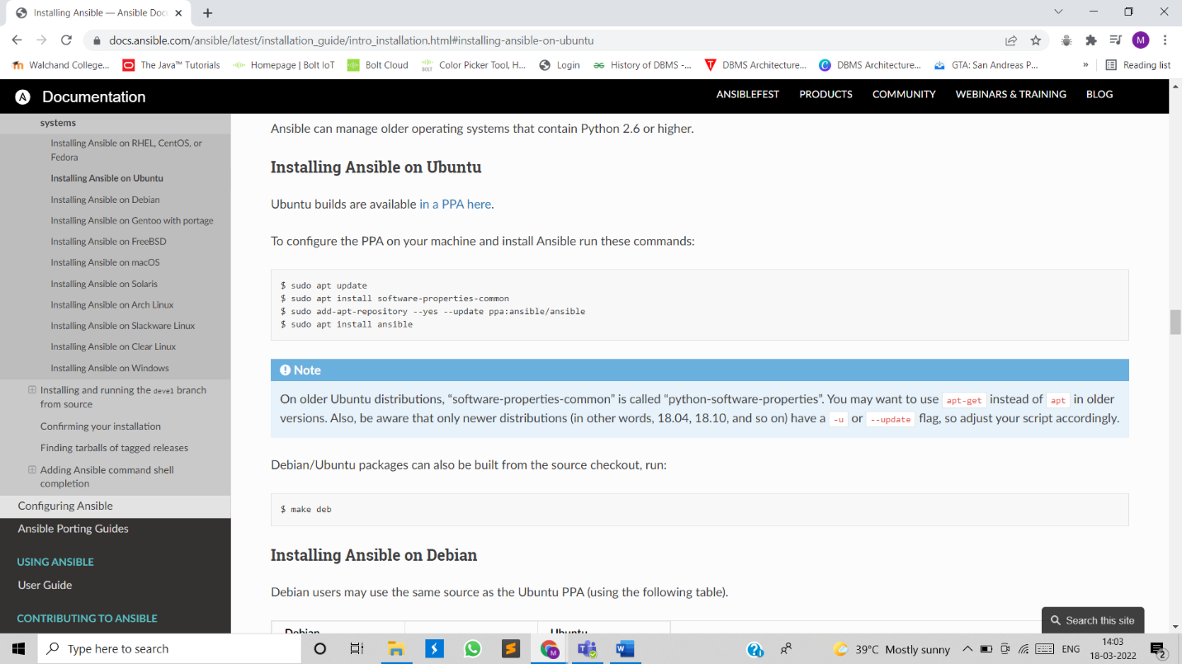

Updated the existing packages:

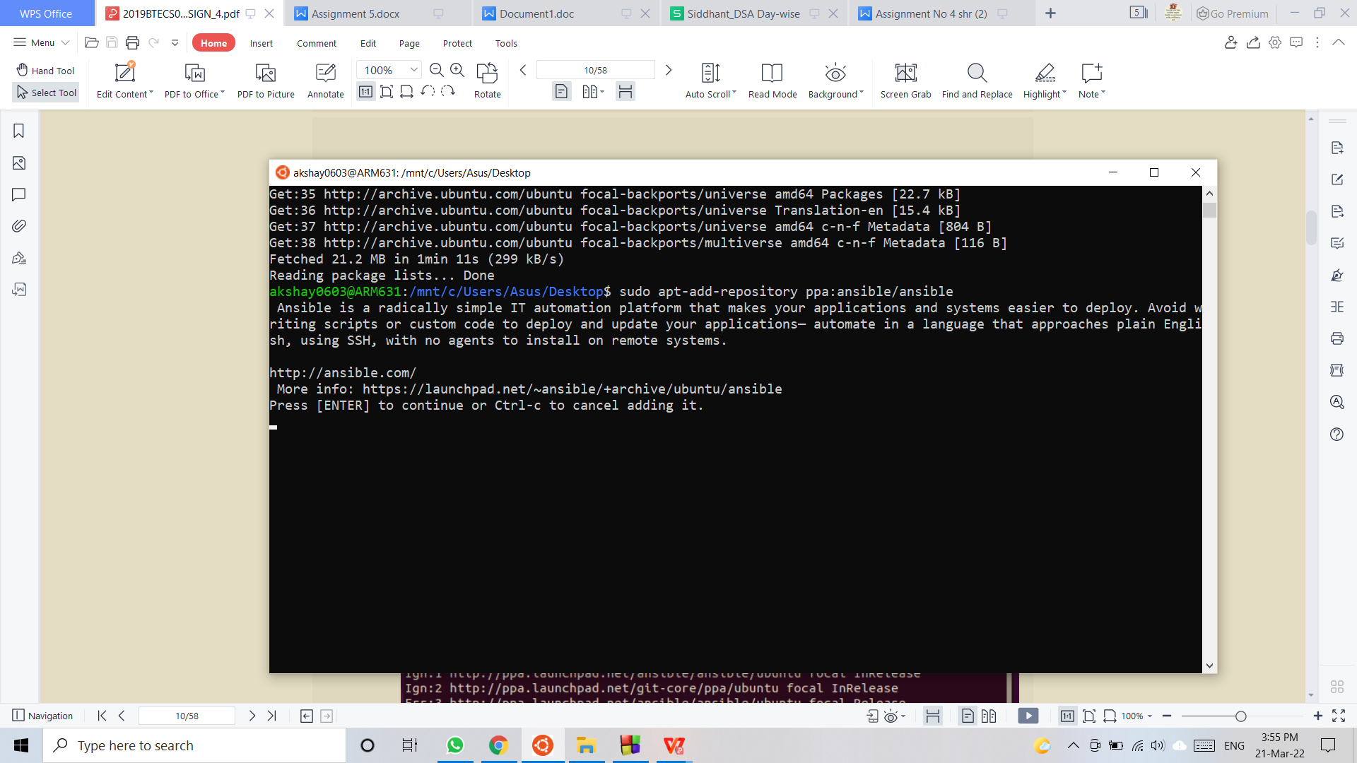

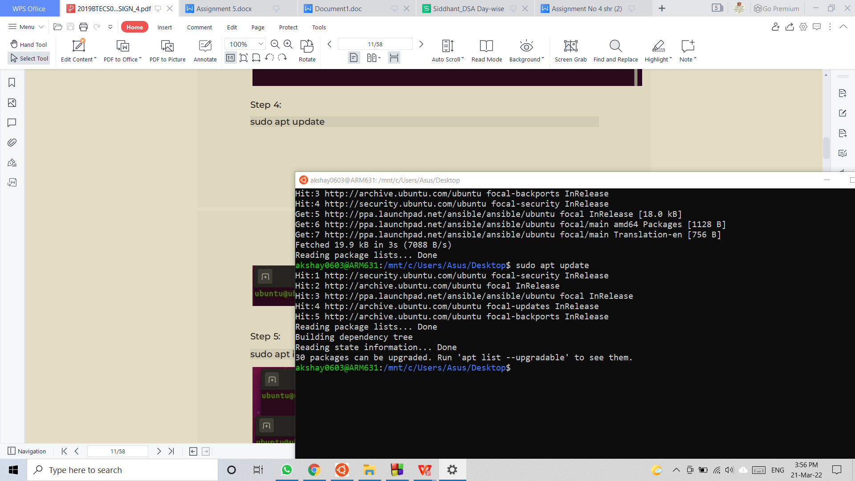

Executed above commands to install ansible:

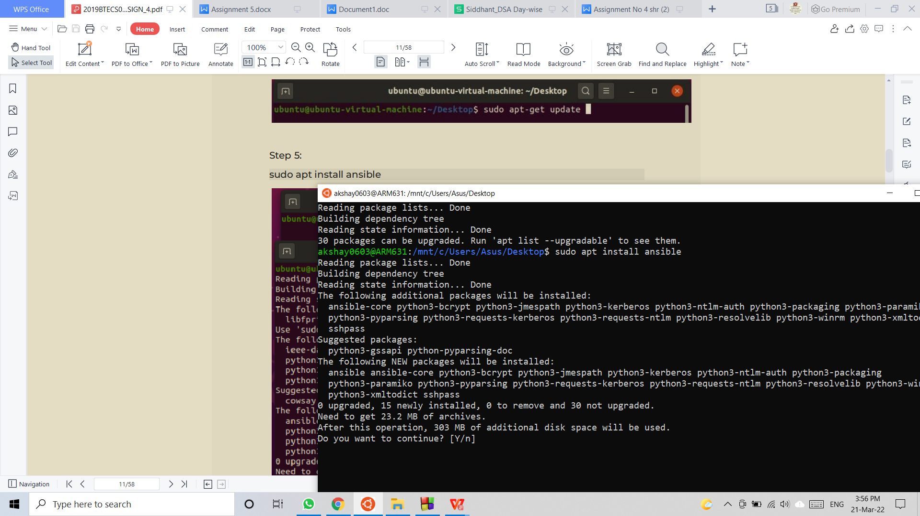

Installation complete.

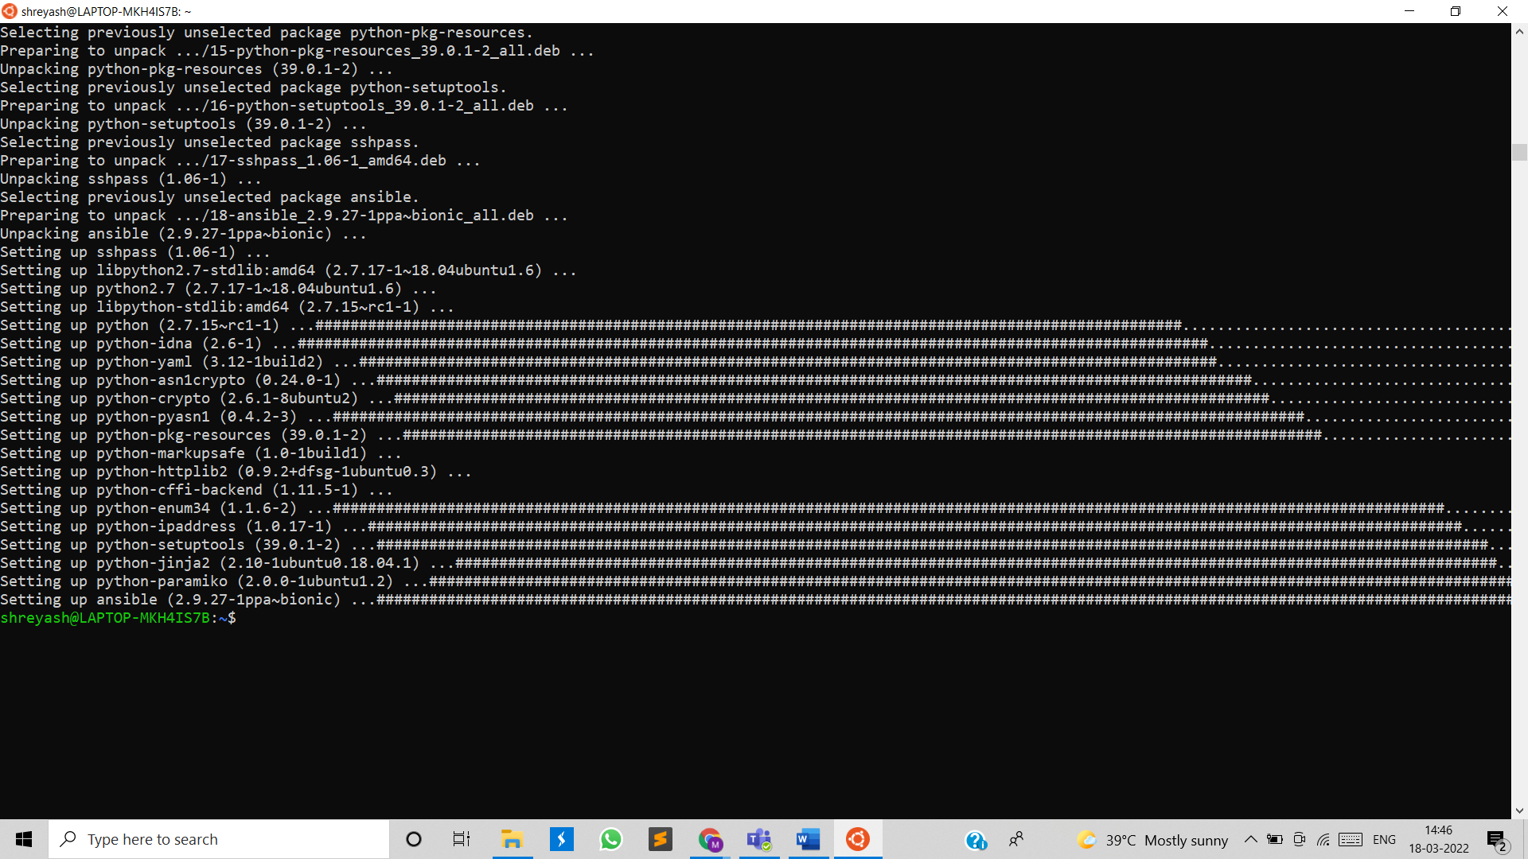

Checked installation of ansible on server:

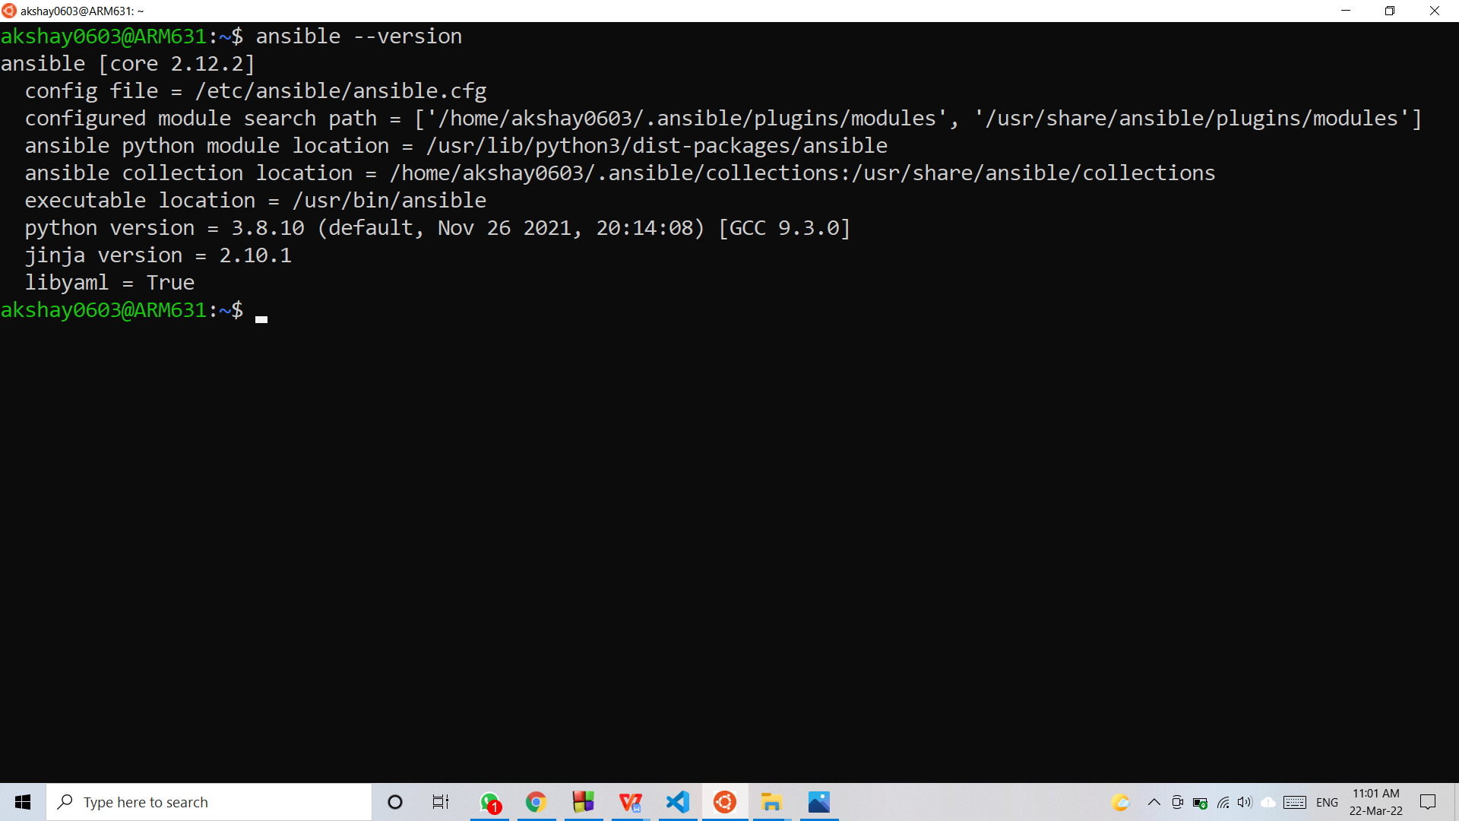

Edited hosts inventory file, added IP address of working node.

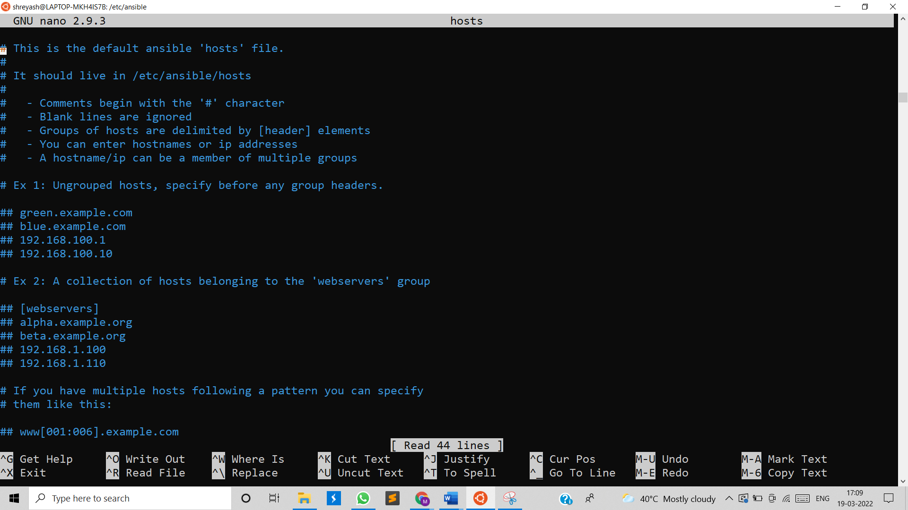

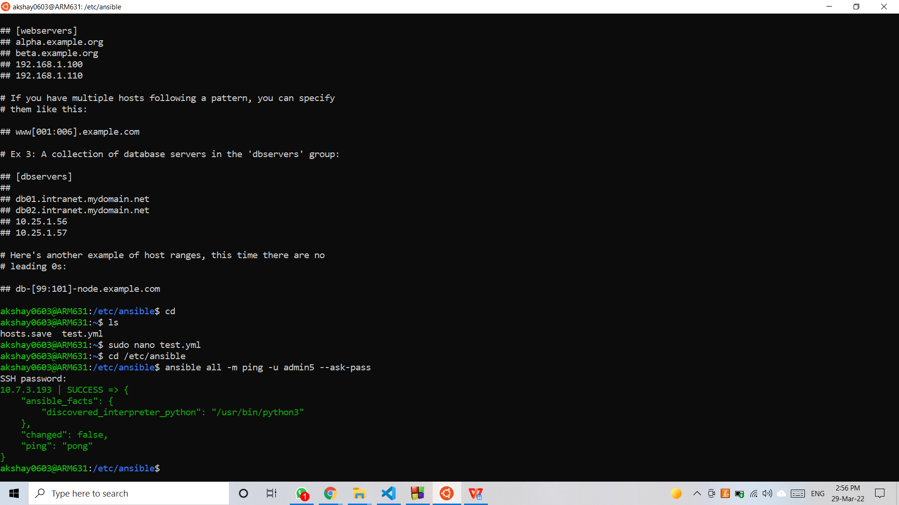

Testing connection with working node:



Creating playbook named test.yml file to install MySQL server on that node.

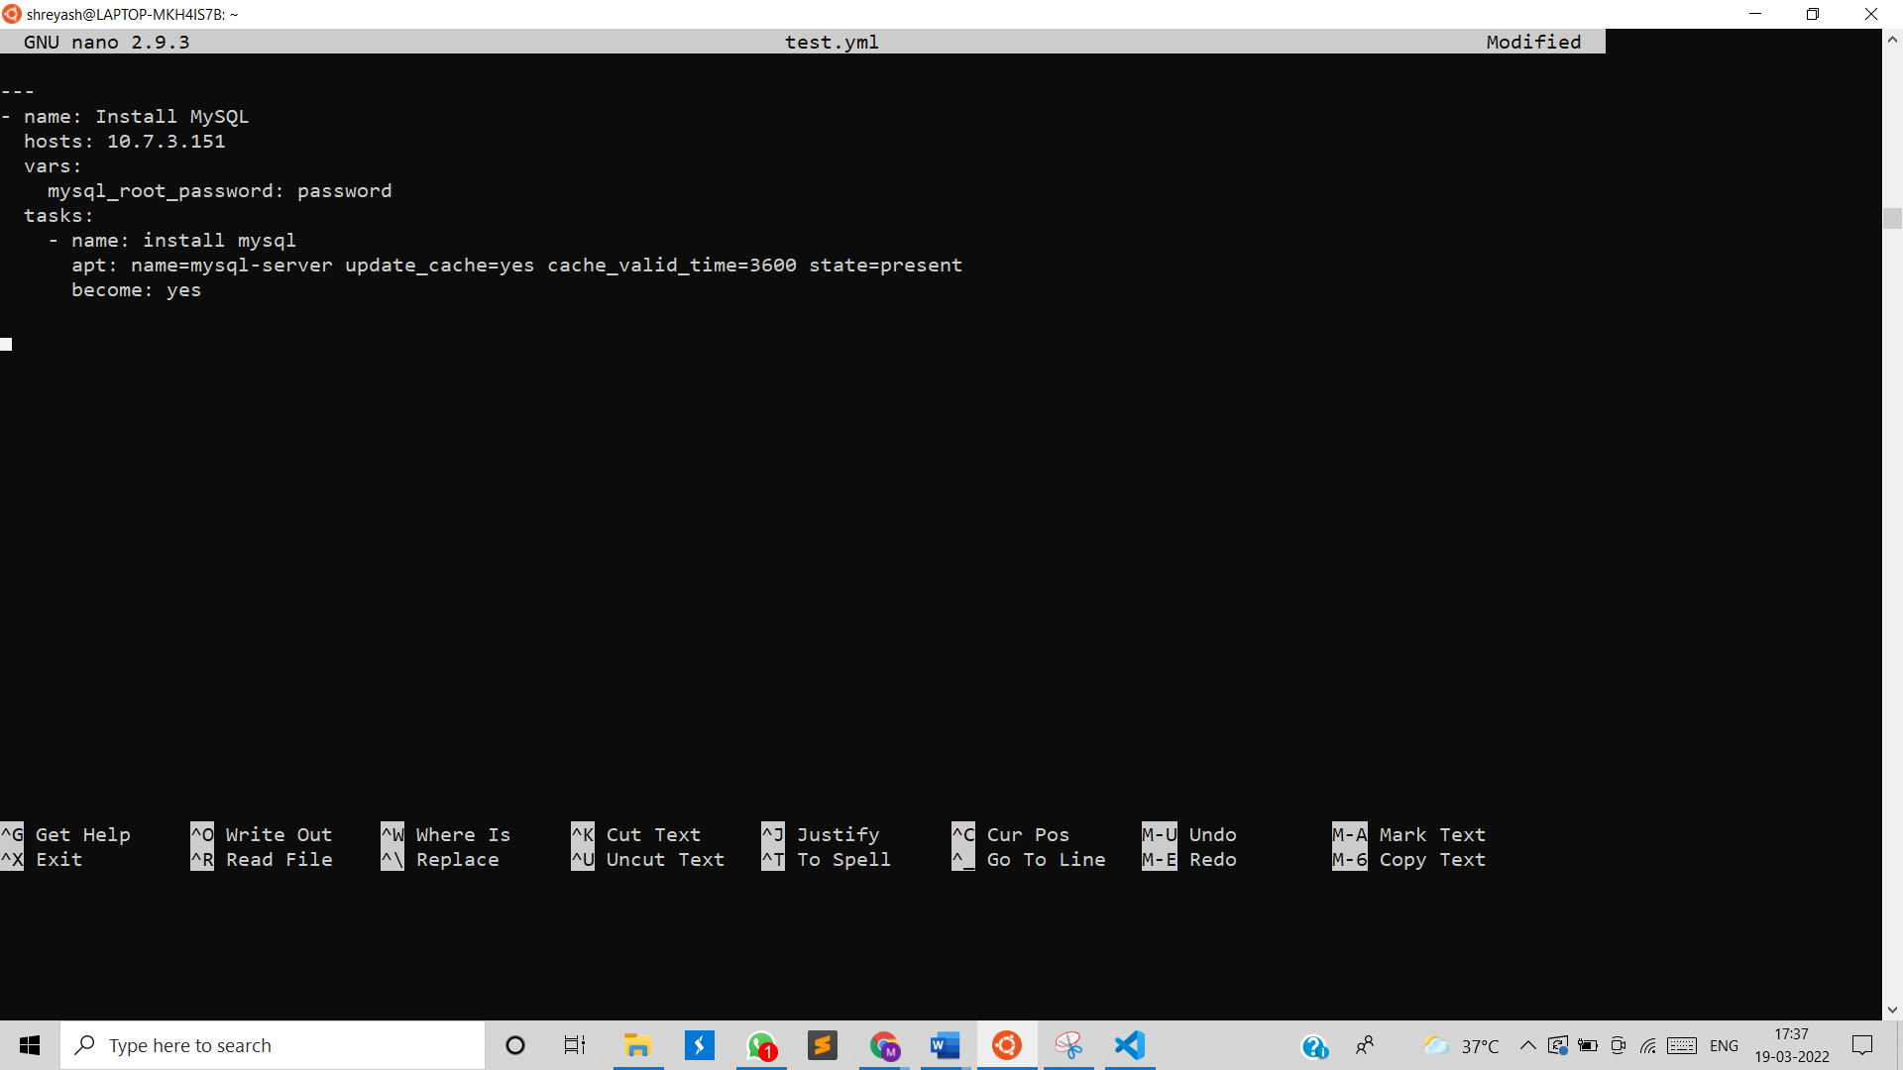

Executed test.yml file for installation.

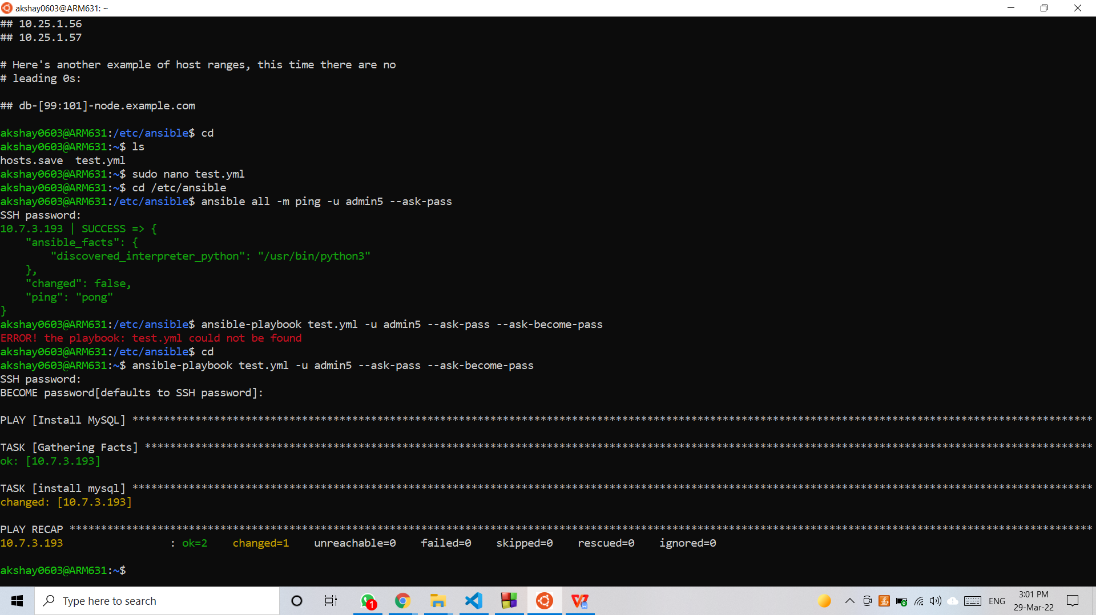

Tested whether the MySQL server installed on node:

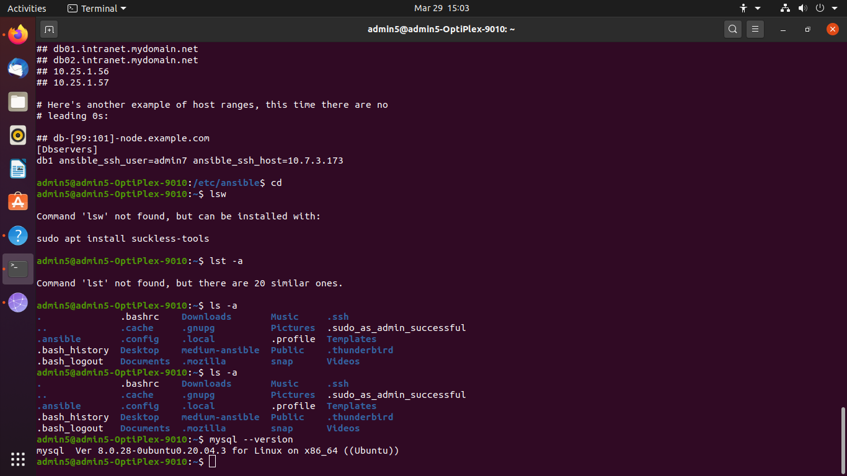

Q 6. Perform below operations on your machine to check **working of Chef**

1. Install Chef
2. Create a recipe and place it in a cookbook to install MySQL db on one node.
3. Execute a recipe using knife command.